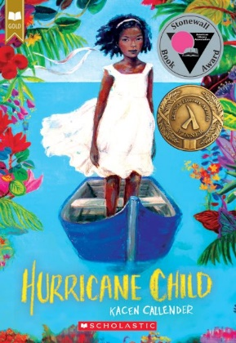
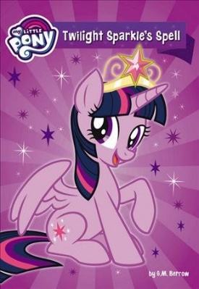
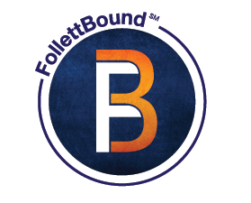
80% OFF FollettBounds!

They’re Baker Bound
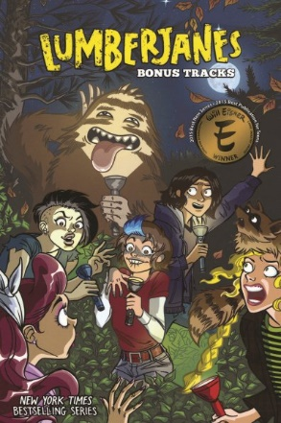
and Taylor Tough!
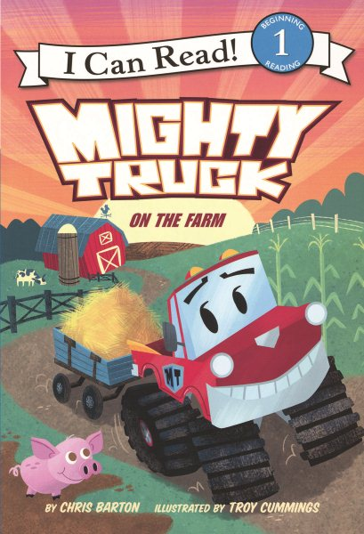
Now through January 31, 2022,
take 80%OFF
prebind editions of popular
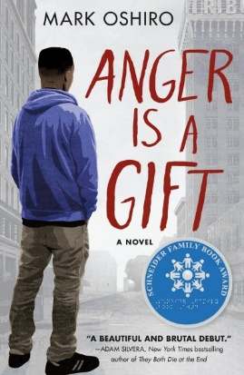
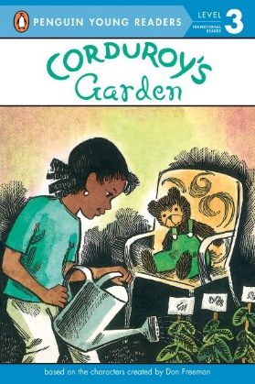
sellers in our Guaranteed Library Binding, including graphic novels,
Spanish & Bilingual titles,
titles for emergent readers, and more!

Quantities are limited,
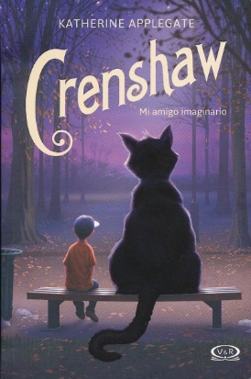
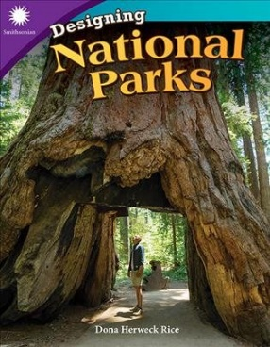
so act now!

Visit TS360 > Children's & Teen >
Baker & Taylor Prebinds: FollettBound
for selection list links.

No promotion code needed.
Discount applied at time of invoice.

